**Adding Family Housing Inspection**

After adding the facility (address) of the housing unit, you will select your location. Using the EH menu select the Habitability survey.

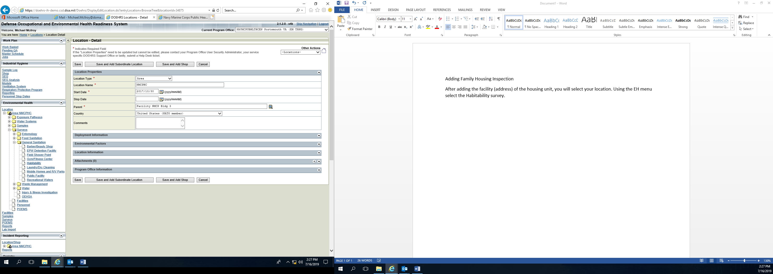

Use the plus (+) icon or the other actions menu to add a survey.

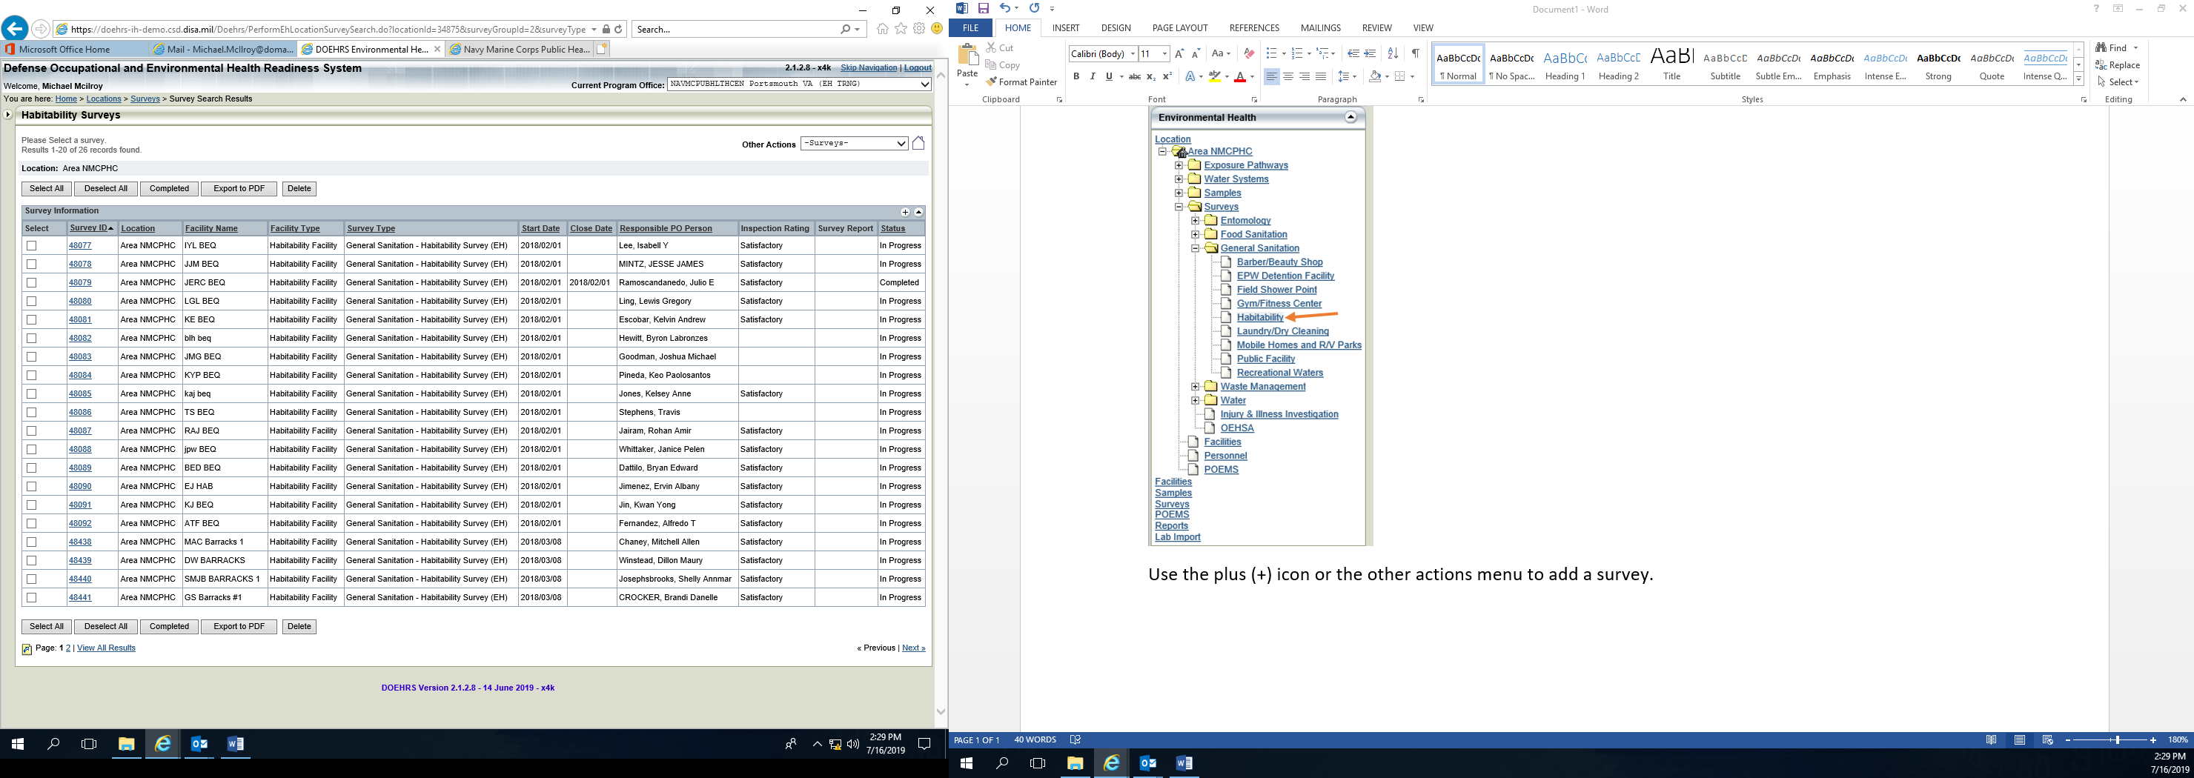

You will enter the Facility Name (address) and click search.

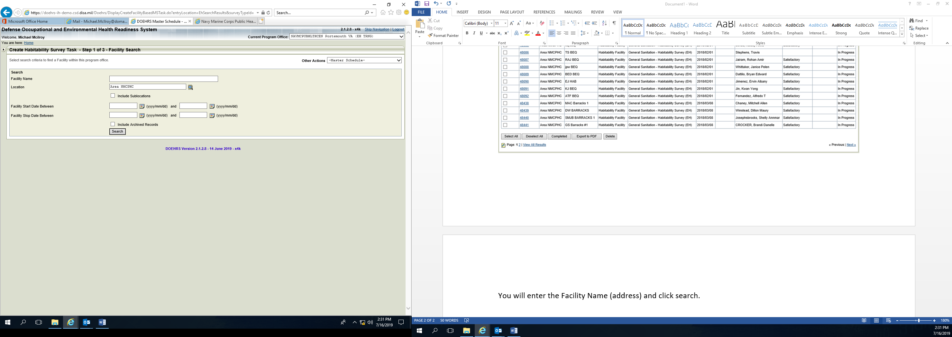

You facility will become visible, select and choose continue.

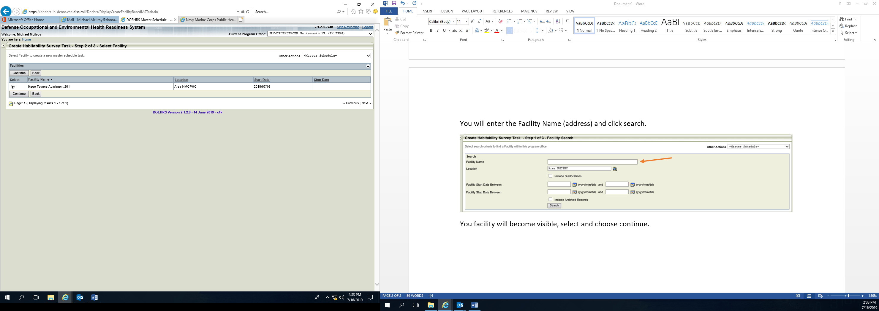

Navy EH does **NOT** utilize the Master Schedule, select ‘Save and Begin Survey’.

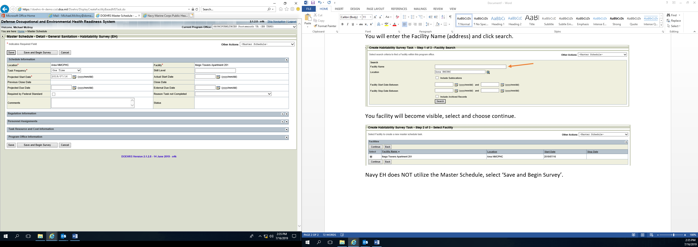

Complete the first 3 sections and select ‘Save and Continue Working’.

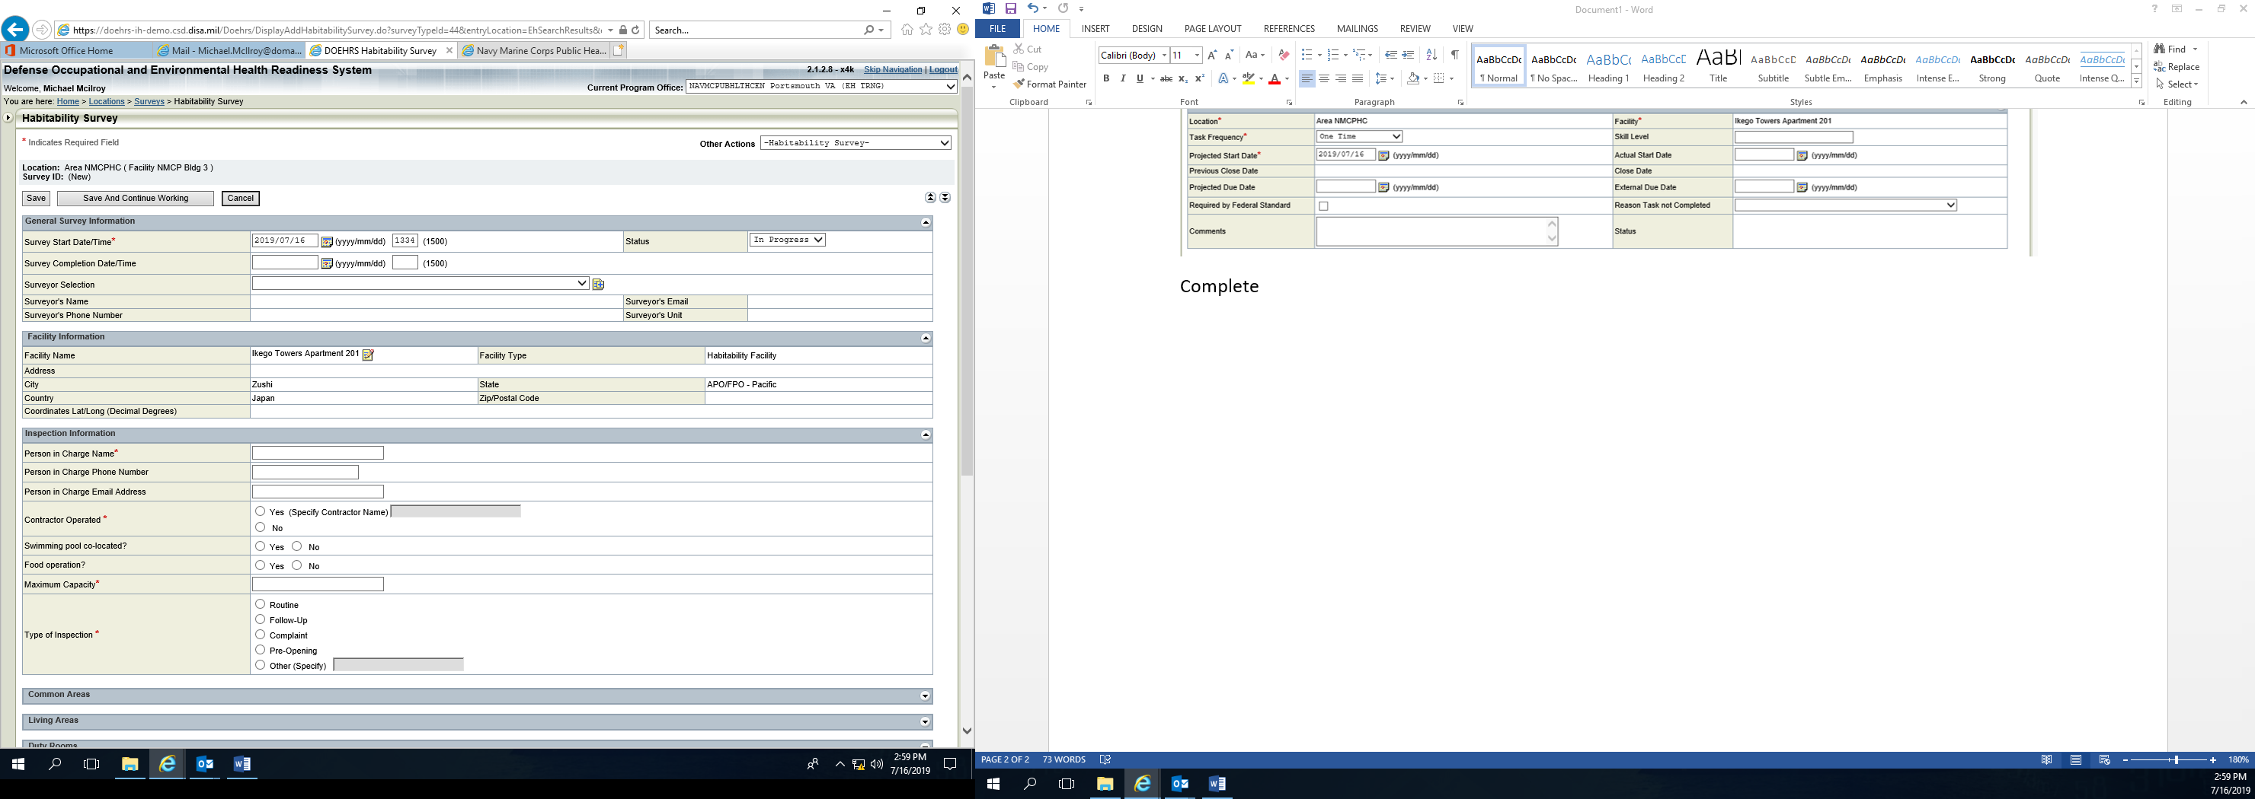

Complete the supplied checklist.

In Overall Inspection Results place facility rating and overall remarks. Scan and attach the check list to DOEHRS form.

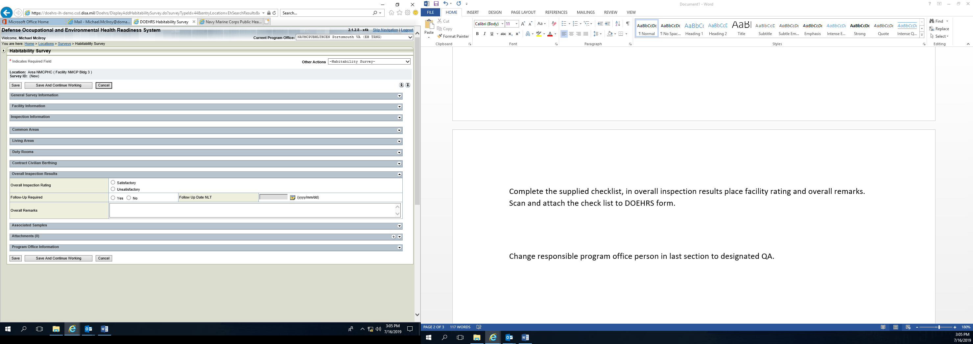

Change responsible program office person in last section to designated QA and select save.

